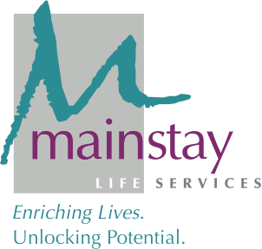

FOR IMMEDIATE RELEASE

CONTACT: Kim Sonafelt Anthony Mendicino
ksonafelt@mainstaylifeservices.org anthony@mindfulkreative.com
412.344.3640 724.825.5143

Mainstay Life Services Appoints Dorothy Gordon
as First Chief Advancement and Engagement Officer (CAEO)
November 15, 2021 (PITTSBURGH, PA) – Mainstay Life Services, a nonprofit organization that provides life-long, high-quality support services to people with developmental disabilities, is pleased to announce the appointment of Dorothy Gordon as its first Chief Advancement and Engagement Officer (CAEO).

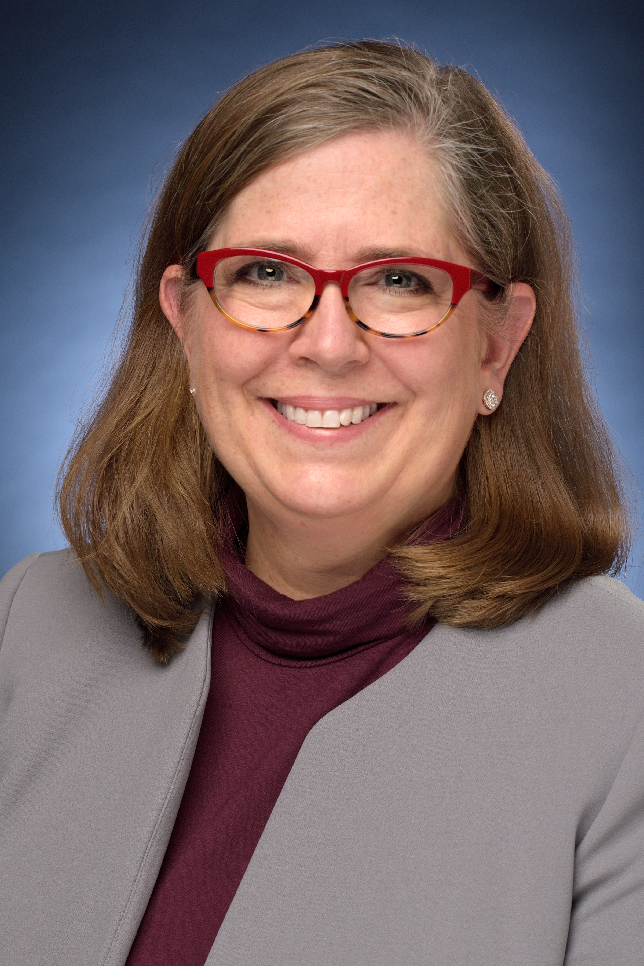
“We’re extremely excited to add Dorothy to our Executive Leadership team,” said Chief Executive Officer Kim Sonafelt. “Her extensive experience and leadership across all aspects of fundraising and communications are crucial to moving Mainstay forward.”

In her new role as CAEO, Gordon will spearhead fundraising efforts and promote Mainstay’s mission through the donor experience. Additionally, she is responsible for leading the effort for raising philanthropic dollars through major giving, annual giving, legacy gifts, grants, and special events.

“Mainstay is such an important part of our community and region,” Gordon said. “As I dive into this work, I’m so honored to play a role in our continued growth and progress, especially on behalf of the people we support and the amazing caregivers we employ.”

Gordon joins Mainstay with over 20 years of leadership in the financial management and nonprofit development sectors. With experience in both for-profit and nonprofit organizations, Gordon brings an extremely well-rounded understanding of fundraising and business to Mainstay’s team. Prior to joining Mainstay, she most recently worked as the Executive Director of Development and Communications at Merakey Allegheny Valley School (AVS) in Coraopolis, Pa., where she was responsible for managing all development activities, including fundraising events and appeals, communications, and community engagement initiatives. There, she led a team that cultivated and grew donor relationships while exceeding annual goals in fundraising by an average of 20% each year since 2012.

In addition to her extensive professional experience, Gordon is a member of the Association of Fundraising Professionals, the Executive Women’s Council, 100 Women Who Care – Pittsburgh Chapter, and serves on the Pittsburgh Allderdice PTO Board.

Gordon earned her bachelor’s degree in Sociology with an emphasis in Business at Franklin & Marshall College and her Master of Business Administration in Marketing, Finance, and Entrepreneurship at the University of Rochester.

# # #

About Mainstay Life Services
Mainstay Life Services is a nonprofit organization providing residential services, community services, and other supports to people with developmental disabilities and their families. We are committed to assisting the people in our care to reach their fullest potentials within their communities.

