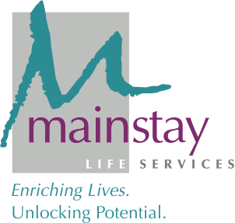

FOR IMMEDIATE RELEASE

CONTACT: Kim Sonafelt Natalie Schlimmer
ksonafelt@mainstaylifeservices.org natalie@mindfulkreative.com
412.344.3640 302.222.0639

Mainstay Life Services Appoints Craig Douglass
as New Chief Program Officer
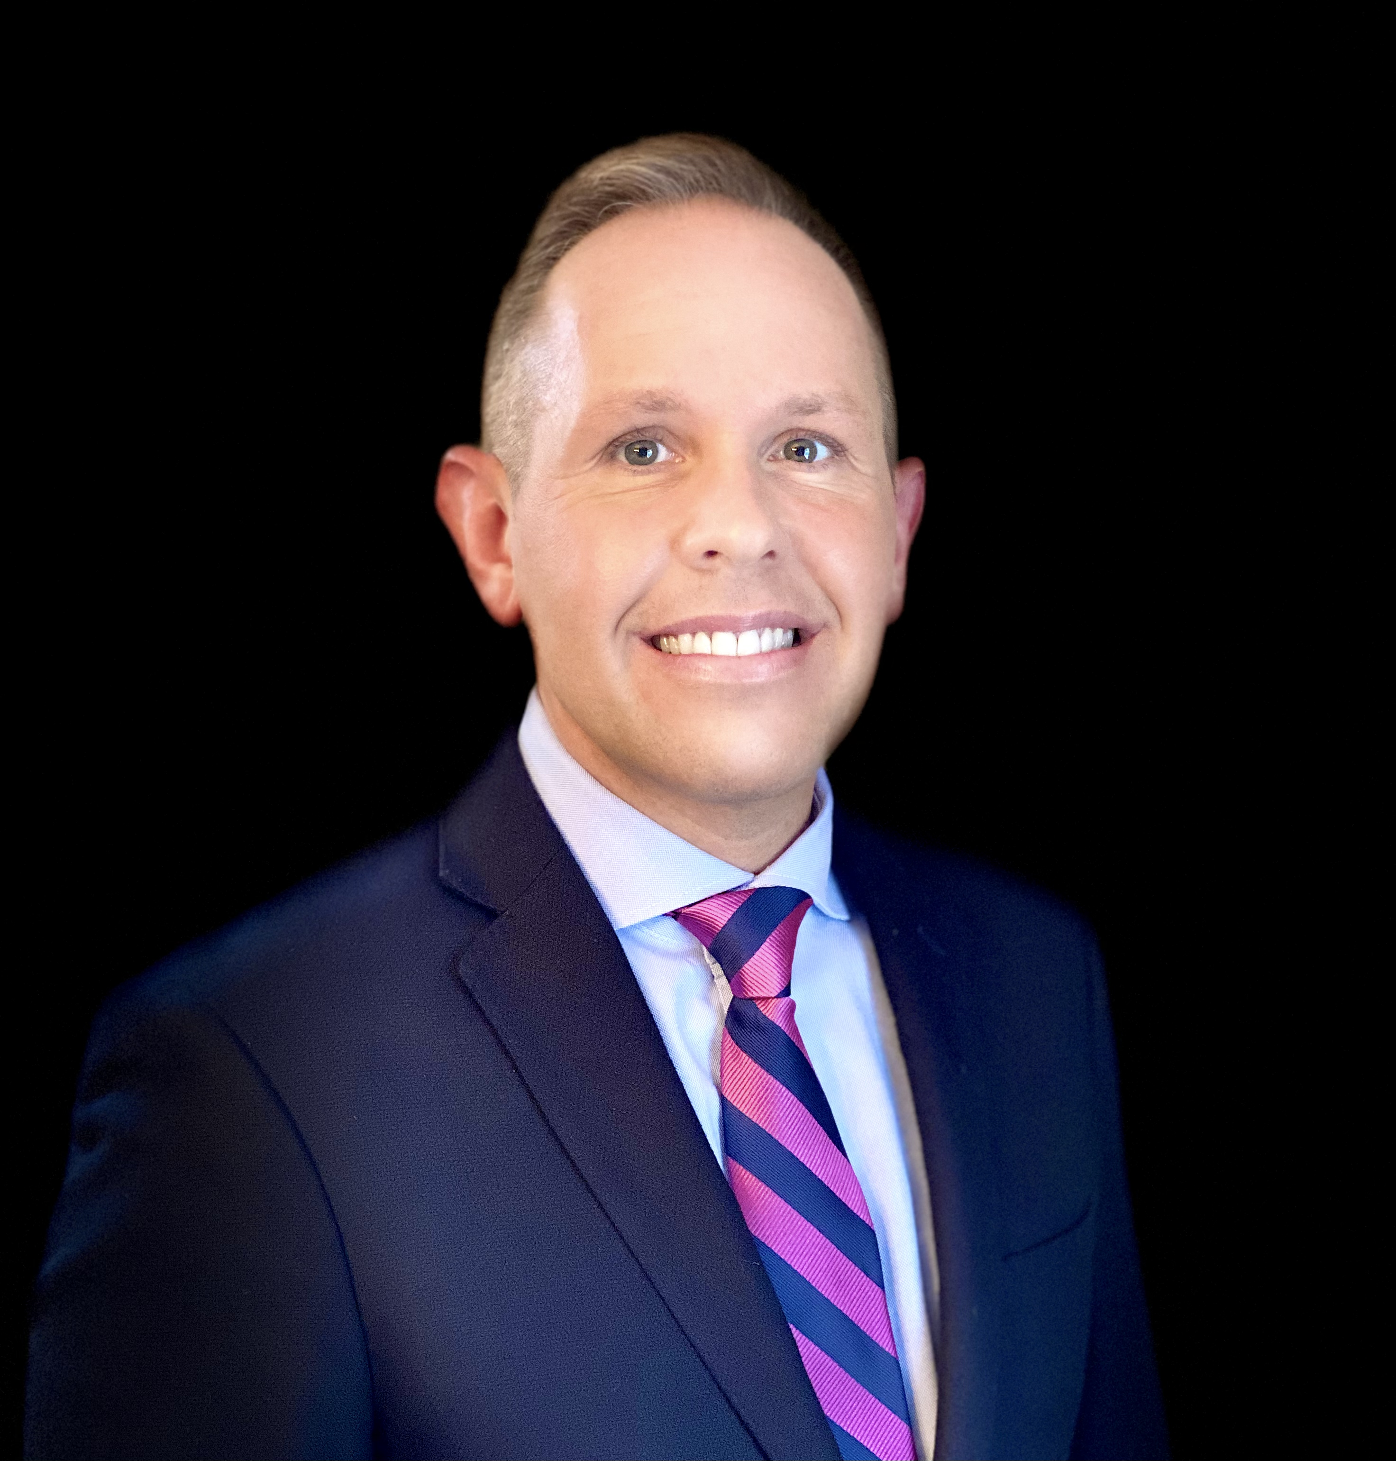
May 24, 2021 (PITTSBURGH, PA) – Mainstay Life Services, a nonprofit organization that provides life-long, high-quality support services to people with developmental disabilities, is pleased to announce the appointment of Craig Douglass as its new Chief Program Officer (CPO).

“We are thrilled to welcome Craig to our team at Mainstay,” said Chief Executive Officer Kim Sonafelt. “Not only does he bring with him an incredible wealth of knowledge and experience, but he will be an essential part of achieving our vision for the future.”

In his role as CPO, Douglass provides strategic leadership for all Mainstay programs – ensuring efficiency, quality, stewardship, and an exceptional experience of care so Mainstay can carry out its mission. Additionally, he is responsible for compliance, program development, and building operating capacity for sustainability and growth.

“Mainstay has such a remarkable reputation in our community and across the region,” Douglass said. “It’s an honor to continue this important work, especially alongside such a committed team.”

Douglass has over 20 years of progressive leadership and consulting experience in community-based healthcare and he has extensive experience in the field of intellectual and developmental disability and autism services. Prior to joining Mainstay, Douglass served as Chief Operations Officer for Pittsburgh Mercy, a subsidiary of Trinity Health, where he had responsibility for ensuring the strategic alignment of clinical and administrative operations, designing and implementing population-based behavioral healthcare, driving profitable revenue growth, exercising programmatic vision to increase market share, and fostering collaboration for $110M multi-campus corporation serving 33 thousand people annually. Douglass is also the principal of CDG Consulting, a firm that specializes in helping organizations navigate the complex world of healthcare compliance, risk management, and service design.

In addition to his professional achievements, Craig volunteers for several community-based organizations, including Footbridge for Families, a start-up organization that focuses on emergency financial relief for families facing economic instability. He has also served as a legal advocate and hotline volunteer for a domestic violence center.

Douglass earned his bachelor’s degree in social science and legal studies and his master’s degree in public policy and management from the University of Pittsburgh.

# # #

About Mainstay Life Services
Mainstay Life Services is a nonprofit organization providing residential services, community services, and other supports to people with developmental disabilities and their families. We are committed to assisting the people in our care to reach their fullest potentials within their communities.

